City of Harrah-Police Department
PO Box 636
Harrah, OK 73045

PERSONAL HISTORY STATEMENT – Peace Officer

Instructions to the Applicant
The information you provide in this Personal History Statement will be used in the background investigation to assist in determining your suitability for the position of Peace Officer.
- It is your responsibility to complete this form and provide all required information.
- Following instructions given by the hiring department, type or neatly print in black ink.
- You must respond to all items and questions. If a question does not apply to you, write “N/A” (not applicable) in the space provided for your response.
- If you need more space for any response, use the supplemental information page on the last page of this form (page 25) and identify the additional information by the question number.
- Following instructions given by the hiring department, provide the completed form to your background investigator or the agency to which you are applying.

Disqualification
There are very few automatic bases for rejection. Even issues of prior misconduct, such as prior illegal drug use, driving under the influence, theft, or even arrest or conviction are usually not, in and of themselves, automatically disqualifying. However, deliberate misstatements or omissions can and often will result in your application being rejected, regardless of the nature or reason for the misstatements/omissions. In fact, the number one reason individuals “fail” background investigations is because they deliberately withhold or misrepresent job-relevant information from their prospective employer.
BOTTOM LINE: You are responsible for providing complete, accurate, and truthful responses.

Disclosure of Medically-Related Information
In accordance with the U.S. Americans with Disabilities Act, the Genetic Information Nondiscrimination Act (GINA), applicants are not expected or required to reveal any medical or other disability-related information about themselves or their family members in response to questions on this form.

I have read and I understand the above instructions.

Signature: _________________________________________________ Date: ________________________

Page 1 of 25

SECTION 1: PERSONAL
1. YOUR FULL NAME
LAST FIRST MIDDLE
2. OTHER NAMES YOU HAVE USED OR BEEN KNOWN BY (INCLUDE MAIDEN NAME AND NICKNAMES) |  |  |  | N/A
3. ADDRESS WHERE YOU LIVE
NUMBER / STREET APT / UNIT
CITY STATE ZIP
4. MAILING ADDRESS, IF DIFFERENT FROM ABOVE (FOR EXAMPLE, PO BOX)

5. CONTACT NUMBERS
HOME ( ) WORK ( ) _{EXT} OTHER ( ) CELL FAX
6. CONTACT EMAIL |  |  | 7. LIST ALL OTHER EMAIL ADDRESSES (SEPARATED BY COMMAS)
8. CITIZENSHIP
Are you a U.S. citizen? ....................................................................................................................................................................... Yes No
IF NO, are you a resident alien who is eligible and has applied for U.S. citizenship? .......................................................................... Yes No
9. BIRTH PLACE (CITY / COUNTY / STATE / COUNTRY)

10. BIRTHDATE (MM/DD/YYYY) | 11. SOCIAL SECURITY NUMBER | 12. DRIVER’S LICENSE
 | – – | NUMBER: STATE: EXPIRES:
13. PHYSICAL DESCRIPTION
HEIGHT: WEIGHT: HAIR COLOR: EYE COLOR:

SECTION 2: RELATIVES AND REFERENCES
14. IMMEDIATE FAMILY
- Provide all applicable information in the spaces below.  - Mark “N/A” if a category is not applicable. |  |  | - Mark “Deceased,” if appropriate.  - If more space is needed, continue on page 25 – reference corresponding numbers.
14.A Spouse / Registered Domestic Partner |  |  |  |  |  | Deceased |  |  |  |  | N/A
NAME |  | HOME ADDRESS (NUMBER / STREET / APT) |  |  | CITY |  |  |  | STATE | ZIP
 | HOME PHONE  ( ) | WORK ADDRESS (NUMBER / STREET / SUITE) |  |  | CITY |  |  |  | STATE | ZIP
 | WORK PHONE | CELL PHONE |  | EMAIL
 | ( ) | ( )
 | DATE OF MARRIAGE/REGISTRATION  / (MM/YYYY) |  |  | Is there, or has there ever been, a restraining or stay-away order in effect involving you and this individual? ....................... Yes No
14.B Former Spouse / Former Registered Domestic Partner
 |  |  |  |  |  |  |  | Deceased |  |  |  |  | N/A
NAME |  | HOME ADDRESS (NUMBER / STREET / APT) |  |  | CITY |  |  |  | STATE | ZIP
 | HOME PHONE  ( ) | WORK ADDRESS (NUMBER / STREET / SUITE) |  |  | CITY |  |  |  | STATE | ZIP
 | WORK PHONE | CELL PHONE |  | EMAIL
 | ( ) | ( )
 | DATE OF MARRIAGE/REGISTRATION | DATE OF DISSOLUTON |  | Is there, or has there ever been, a restraining or stay-away order in effect involving you and this individual? ....................... Yes No
 | / (MM/YYYY) | / (MM/YYYY)
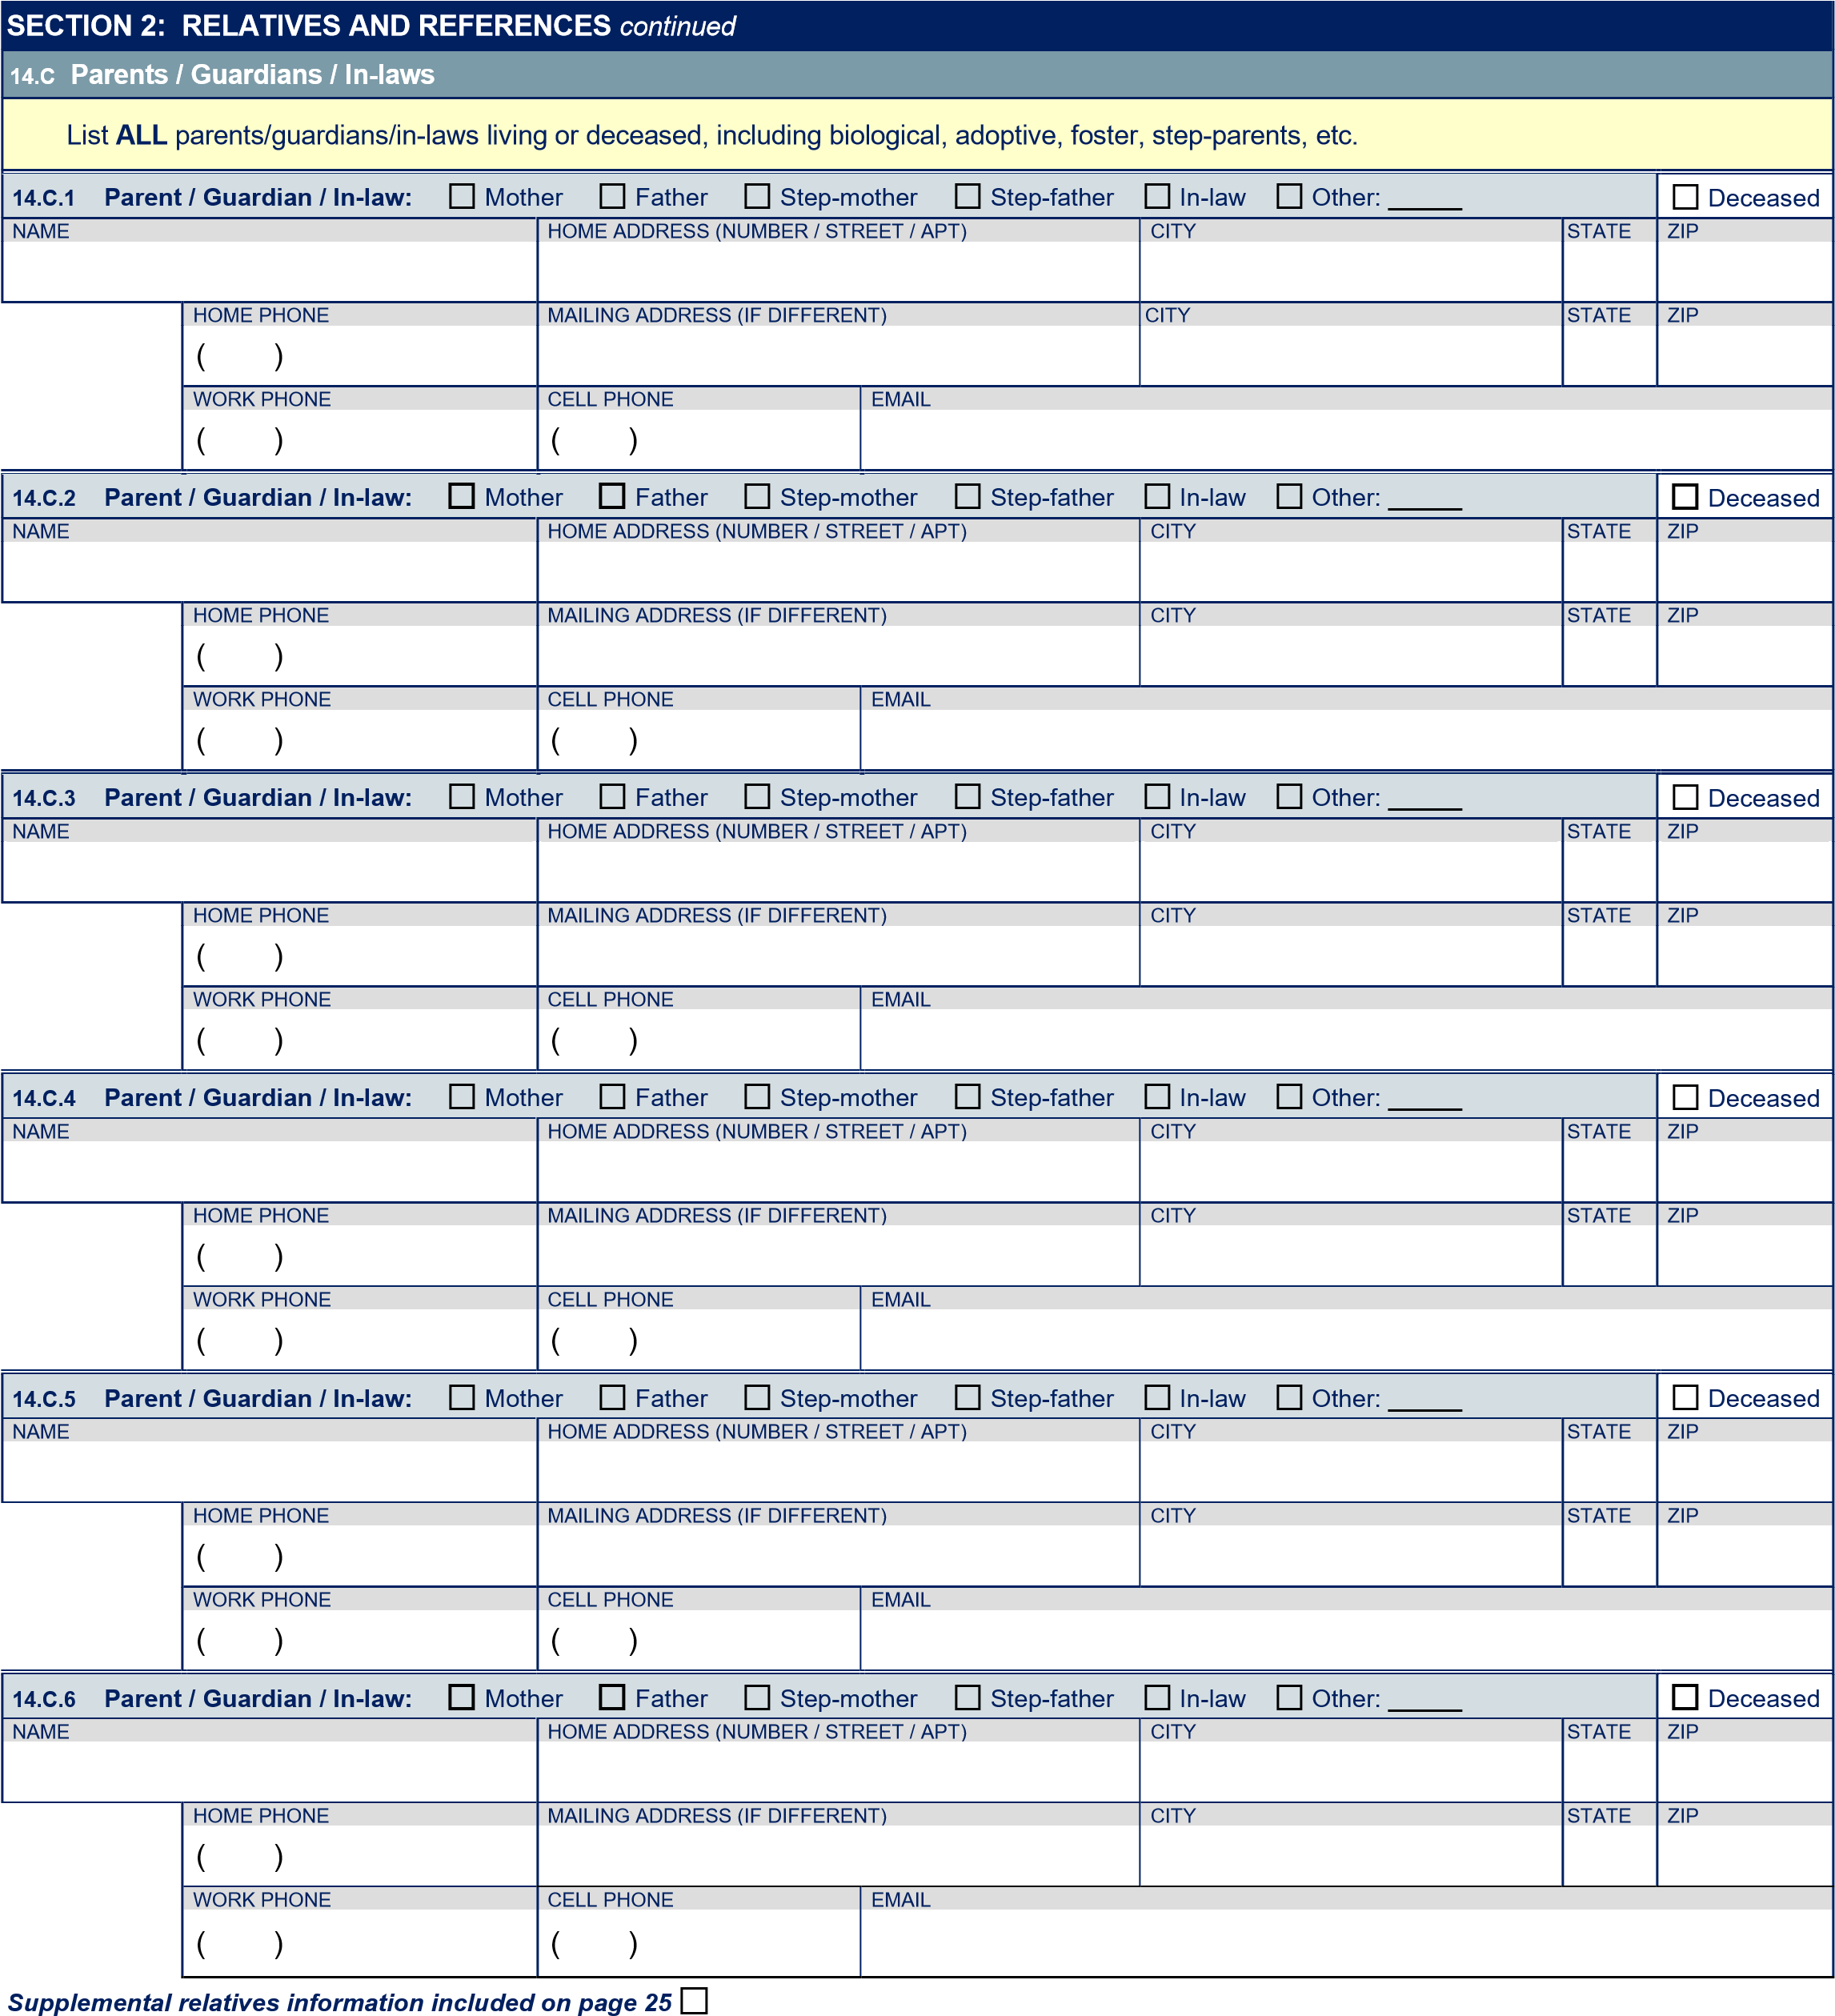

SECTION 2: RELATIVES AND REFERENCES continued
14.D Brothers / Sisters
 |  |  |  |  |  |  |  |  |  |  |  |  |  |  |  |  |  | N/A
List ALL LIVING siblings, including half-siblings, step-siblings, foster-siblings, etc.
14.D.1 Sibling: |  |  | Brother |  | Sister |  |  | Half-brother |  | Half-sister |  |  | Other:
NAME |  |  |  |  |  | AGE |  | HOME ADDRESS (NUMBER / STREET / APT) |  |  |  |  |  | CITY | STATE | ZIP
 | HOME PHONE  ( ) |  |  |  |  |  |  | MAILING ADDRESS (IF DIFFERENT) |  |  |  |  |  | CITY | STATE | ZIP
 | WORK PHONE |  |  |  |  |  |  | CELL PHONE |  |  | EMAIL
 | ( ) |  |  |  |  |  |  | ( )
14.D.2 Sibling: |  |  | Brother |  | Sister |  |  | Half-brother |  | Half-sister |  |  | Other:
NAME |  |  |  |  |  | AGE |  | HOME ADDRESS (NUMBER / STREET / APT) |  |  |  |  |  | CITY | STATE | ZIP
 | HOME PHONE  ( ) |  |  |  |  |  |  | MAILING ADDRESS (IF DIFFERENT) |  |  |  |  |  | CITY | STATE | ZIP
 | WORK PHONE |  |  |  |  |  |  | CELL PHONE |  |  | EMAIL
 | ( ) |  |  |  |  |  |  | ( )
14.D.3 Sibling: |  |  | Brother |  | Sister |  |  | Half-brother |  | Half-sister |  |  | Other:
NAME |  |  |  |  |  | AGE |  | HOME ADDRESS (NUMBER / STREET / APT) |  |  |  |  |  | CITY | STATE | ZIP
 | HOME PHONE  ( ) |  |  |  |  |  |  | MAILING ADDRESS (IF DIFFERENT) |  |  |  |  |  | CITY | STATE | ZIP
 | WORK PHONE |  |  |  |  |  |  | CELL PHONE |  |  | EMAIL
 | ( ) |  |  |  |  |  |  | ( )
14.D.4 Sibling: |  |  | Brother |  | Sister |  |  | Half-brother |  | Half-sister |  |  | Other:
NAME |  |  |  |  |  | AGE |  | HOME ADDRESS (NUMBER / STREET / APT) |  |  |  |  |  | CITY | STATE | ZIP
 | HOME PHONE  ( ) |  |  |  |  |  |  | MAILING ADDRESS (IF DIFFERENT) |  |  |  |  |  | CITY | STATE | ZIP
 | WORK PHONE |  |  |  |  |  |  | CELL PHONE |  |  | EMAIL
 | ( ) |  |  |  |  |  |  | ( )

Supplemental relatives information included on page 25

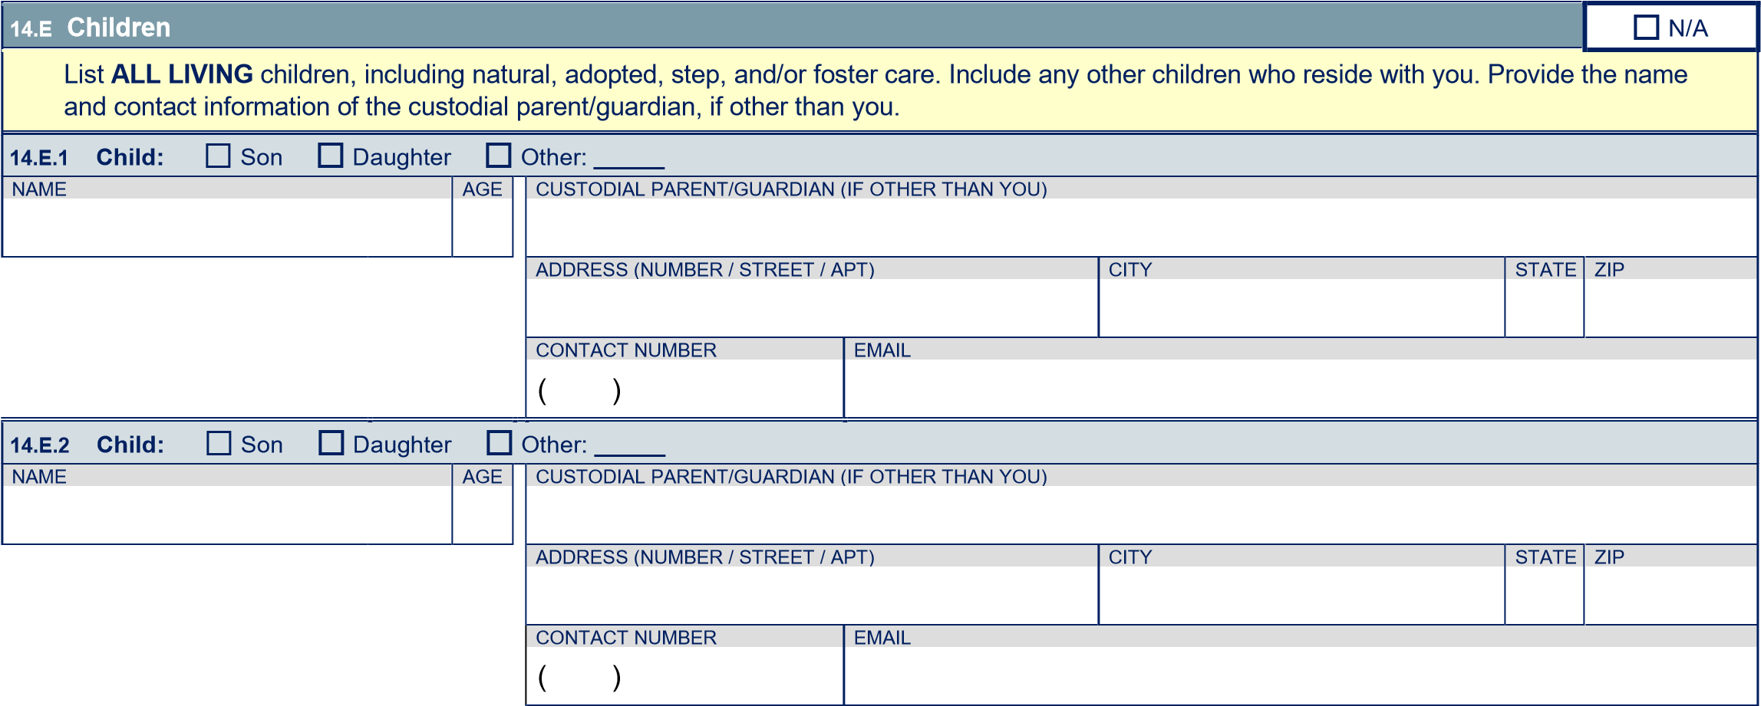

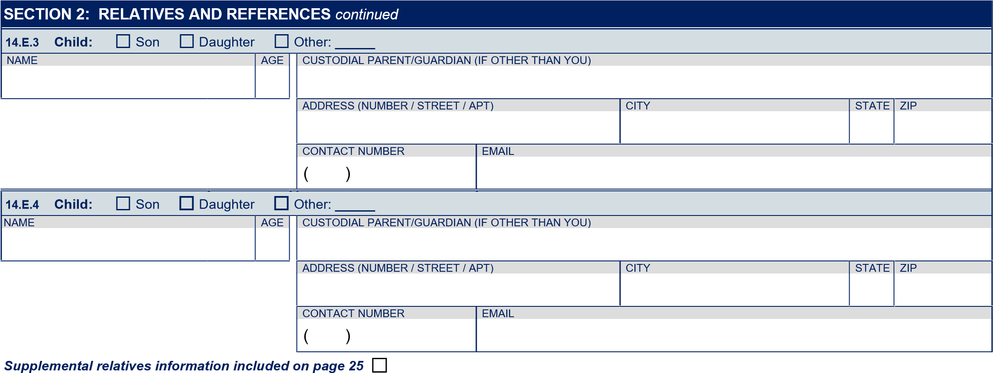
 | 15. LIST OF REFERENCES
 | • List 7-10 people who know you well, such as close personal relationships, social and family friends, teachers, military colleagues, and/or co-workers. Do NOT include relatives, employers, housemates, or any individuals listed elsewhere.
 | 15.1 |  | NAME OF REFERENCE |  |  |  | HOME ADDRESS (NUMBER / STREET / APT) |  |  |  | CITY |  | STATE |  | ZIP
 |  |  |  |  | HOME PHONE  ( ) |  | WORK ADDRESS (NUMBER / STREET / SUITE) |  |  |  | CITY |  | STATE |  | ZIP
 |  |  |  |  | WORK PHONE |  | CELL PHONE |  | EMAIL
 |  |  |  |  | ( ) |  | ( )
 |  |  |  |  | How do you know this person? |  |  |  |  |  | How long have you known this person?
 | 15.2 |  | NAME OF REFERENCE |  |  |  | HOME ADDRESS (NUMBER / STREET / APT) |  |  |  | CITY |  | STATE |  | ZIP
 |  |  |  |  | HOME PHONE  ( ) |  | WORK ADDRESS (NUMBER / STREET / SUITE) |  |  |  | CITY |  | STATE |  | ZIP
 |  |  |  |  | WORK PHONE |  | CELL PHONE |  | EMAIL
 |  |  |  |  | ( ) |  | ( )
 |  |  |  |  | How do you know this person? |  |  |  |  |  | How long have you known this person?
 | 15.3 |  | NAME OF REFERENCE |  |  |  | HOME ADDRESS (NUMBER / STREET / APT) |  |  |  | CITY |  | STATE |  | ZIP
 |  |  |  |  | HOME PHONE  ( ) |  | WORK ADDRESS (NUMBER / STREET / SUITE) |  |  |  | CITY |  | STATE |  | ZIP
 |  |  |  |  | WORK PHONE |  | CELL PHONE |  | EMAIL
 |  |  |  |  | ( ) |  | ( )
 |  |  |  |  | How do you know this person? |  |  |  |  |  | How long have you known this person?
 | 15.4 |  | NAME OF REFERENCE |  |  |  | HOME ADDRESS (NUMBER / STREET / APT) |  |  |  | CITY |  | STATE |  | ZIP
 |  |  |  |  | HOME PHONE  ( ) |  | WORK ADDRESS (NUMBER / STREET / SUITE) |  |  |  | CITY |  | STATE |  | ZIP
 |  |  |  |  | WORK PHONE |  | CELL PHONE |  | EMAIL
 |  |  |  |  | ( ) |  | ( )
 |  |  |  |  | How do you know this person? |  |  |  |  |  | How long have you known this person?
SECTION 2: RELATIVES AND REFERENCES continued
15.5 |  | NAME OF REFERENCE |  |  |  | HOME ADDRESS (NUMBER / STREET / APT) |  |  |  | CITY |  | STATE |  | ZIP
 |  |  |  | HOME PHONE  ( ) |  | WORK ADDRESS (NUMBER / STREET / SUITE) |  |  |  | CITY |  | STATE |  | ZIP
 |  |  |  | WORK PHONE |  | CELL PHONE |  | EMAIL
 |  |  |  | ( ) |  | ( )
 |  |  |  | How do you know this person? |  |  |  |  |  | How long have you known this person?
15.6 |  | NAME OF REFERENCE |  |  |  | HOME ADDRESS (NUMBER / STREET / APT) |  |  |  | CITY |  | STATE |  | ZIP
 |  |  |  | HOME PHONE  ( ) |  | WORK ADDRESS (NUMBER / STREET / SUITE) |  |  |  | CITY |  | STATE |  | ZIP
 |  |  |  | WORK PHONE |  | CELL PHONE |  | EMAIL
 |  |  |  | ( ) |  | ( )
 |  |  |  | How do you know this person? |  |  |  |  |  | How long have you known this person?
15.7 |  | NAME OF REFERENCE |  |  |  | HOME ADDRESS (NUMBER / STREET / APT) |  |  |  | CITY |  | STATE |  | ZIP
 |  |  |  | HOME PHONE  ( ) |  | WORK ADDRESS (NUMBER / STREET / SUITE) |  |  |  | CITY |  | STATE |  | ZIP
 |  |  |  | WORK PHONE |  | CELL PHONE |  | EMAIL
 |  |  |  | ( ) |  | ( )
 |  |  |  | How do you know this person? |  |  |  |  |  | How long have you known this person?
15.8 |  | NAME OF REFERENCE |  |  |  | HOME ADDRESS (NUMBER / STREET / APT) |  |  |  | CITY |  | STATE |  | ZIP
 |  |  |  | HOME PHONE  ( ) |  | WORK ADDRESS (NUMBER / STREET / SUITE) |  |  |  | CITY |  | STATE |  | ZIP
 |  |  |  | WORK PHONE |  | CELL PHONE |  | EMAIL
 |  |  |  | ( ) |  | ( )
 |  |  |  | How do you know this person? |  |  |  |  |  | How long have you known this person?
15.9 |  | NAME OF REFERENCE |  |  |  | HOME ADDRESS (NUMBER / STREET / APT) |  |  |  | CITY |  | STATE |  | ZIP
 |  |  |  | HOME PHONE  ( ) |  | WORK ADDRESS (NUMBER / STREET / SUITE) |  |  |  | CITY |  | STATE |  | ZIP
 |  |  |  | WORK PHONE |  | CELL PHONE |  | EMAIL
 |  |  |  | ( ) |  | ( )
 |  |  |  | How do you know this person? |  |  |  |  |  | How long have you known this person?
15.10 |  | NAME OF REFERENCE |  |  |  | HOME ADDRESS (NUMBER / STREET / APT) |  |  |  | CITY |  | STATE |  | ZIP
 |  |  |  | HOME PHONE  ( ) |  | WORK ADDRESS (NUMBER / STREET / SUITE) |  |  |  | CITY |  | STATE |  | ZIP
 |  |  |  | WORK PHONE |  | CELL PHONE |  | EMAIL
 |  |  |  | ( ) |  | ( )
 |  |  |  | How do you know this person? |  |  |  |  |  | How long have you known this person?

Supplemental references information included on page 25
SECTION 3: EDUCATION
- NOTE: You will be required to furnish transcripts or other proof to support all of your educational claims in Section 3.
- If more space is needed, continue your response on page 25.

16. CHECK APPLICABLE | MM/YYYY |  | MM/YYYY |  | MM/YYYY
High School Diploma: | / | High School Equivalency Test: | / | California High School Proficiency Certificate: | /

17. LIST HIGH SCHOOL(S) ATTENDED
17.1 | NAME OF HIGH SCHOOL |  | FROM (MM/YYYY) / | TO (MM/YYYY)  /
 |  | CITY |  | STATE
17.2 | NAME OF HIGH SCHOOL |  | FROM (MM/YYYY) / | TO (MM/YYYY)  /
 |  | CITY |  | STATE

18. LIST ALL COLLEGES AND UNIVERSITIES ATTENDED
18.1 | NAME OF COLLEGE/UNIVERSITY |  | FROM (MM/YYYY)  / |  | TO (MM/YYYY)  / |  | TOTAL UNITS COMPLETED  QTR SYSTEM ^{SEM SYSTEM}
 |  | ADDRESS (NUMBER / STREET) |  |  |  |  |  | DEGREE EARNED
 |  |  |  |  |  |  |  |  | YES _{NO} _{TYPE:}
 |  | CITY |  | STATE |  | ZIP |  | MAJOR / AREA OF STUDY
18.2 | NAME OF COLLEGE/UNIVERSITY |  | FROM (MM/YYYY)  / |  | TO (MM/YYYY)  / |  | TOTAL UNITS COMPLETED  QTR SYSTEM ^{SEM SYSTEM}
 |  | ADDRESS (NUMBER / STREET) |  |  |  |  |  | DEGREE EARNED  YES _{NO} _{TYPE:}
 |  | CITY |  | STATE |  | ZIP |  | MAJOR / AREA OF STUDY
18.3 | NAME OF COLLEGE/UNIVERSITY |  | FROM (MM/YYYY)  / |  | TO (MM/YYYY)  / |  | TOTAL UNITS COMPLETED  QTR SYSTEM ^{SEM SYSTEM}
 |  | ADDRESS (NUMBER / STREET) |  |  |  |  |  | DEGREE EARNED  YES _{NO} _{TYPE:}
 |  | CITY |  | STATE |  | ZIP |  | MAJOR / AREA OF STUDY

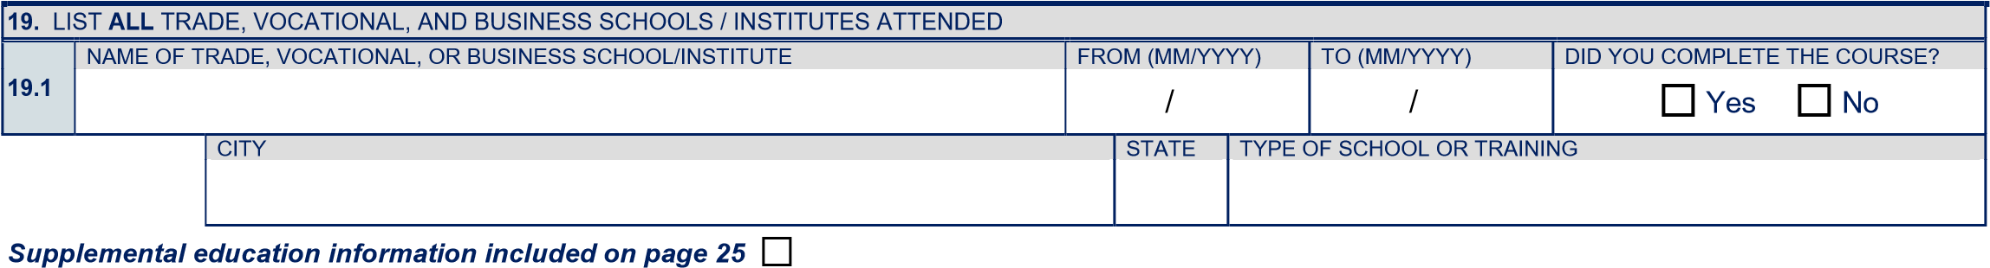

 | LIST ALL POST BASIC COURSES ATTENDED
 | 20. Have you ever taken a PC832 (Arrest and/or Firearms) Course? ....................................................................................................  IF YES, provide the following information: |  |  |  |  |  |  |  |  |  |  |  |  | Yes |  |  |  | No
 |  |  | A. COURSE PRESENTER NAME |  |  |  |  | LOCATION (CITY / STATE)
 |  |  | B. COURSE COMPLETION |  |  |  |  |  |  | COMPLETION DATE (MM/YYYY)
 |  |  | Did you successfully complete the course? .................................................................. Yes No |  |  |  |  |  |  | /
SECTION 3: EDUCATION continued
21. Have you ever attended a POST Basic Course/Academy: Regular, Modular, Specialized Investigators’, Reserve, or Dispatcher?  IF YES, provide the following information: |  |  |  |  |  |  |  |  |  |  |  |  |  |  | Yes |  |  |  | No
21.1 |  | NAME OF COURSE PRESENTER/ACADEMY |  |  |  |  | FROM (MM/YYYY) / |  | TO (MM/YYYY)  / |  | DID YOU PASS/GRADUATE?  Yes No
 |  | LOCATION (CITY, STATE) |  | NAME OF TRAINING OFFICER / ACADEMY COORDINATOR |  |  |  |  |  |  | CONTACT NUMBER ( )
21.2 |  | NAME OF COURSE PRESENTER/ACADEMY |  |  |  |  | FROM (MM/YYYY) / |  | TO (MM/YYYY)  / |  | DID YOU PASS/GRADUATE?  Yes No
 |  | LOCATION (CITY, STATE) |  | NAME OF TRAINING OFFICER / ACADEMY COORDINATOR |  |  |  |  |  |  | CONTACT NUMBER ( )
 |  | Supplemental POST basic course information included on Page 25
22. Have you ever been subject to any disciplinary action, including academic probation, civil fine, suspension, or expulsion from any high school(s), college/university, business, trade school, or POST basic course/academy? ............................................ Yes No
IF YES, describe in detail below. Starting with high school, list any and all disciplinary actions received in any school, educational institution, or POST basic course academy. Include when the disciplinary action(s) occurred, name of school(s), and explanation of circumstances.
________________________________ ______________________________________________________________________
______________________________________________________________________________________________________
______________________________________________________________________________________________________
______________________________________________________________________________________________________
______________________________________________________________________________________________________
23. Since the age of 18, have you cheated on an exam, or assisted another person in cheating on an exam, or participated in cheating on any POST exam? ......................................................................................................................................................... Yes No
IF YES, explain circumstances.
________________________________ ______________________________________________________________________
______________________________________________________________________________________________________
______________________________________________________________________________________________________
______________________________________________________________________________________________________
______________________________________________________________________________________________________

SECTION 4: RESIDENCE HISTORY
24. LIST OF RESIDENCES
- List all residences during the last 10 years or since age 15.
- Provide complete addresses (include markers such as Street, Drive, Road, East, West, etc., and unit/apt/dormitory). Do NOT use PO Boxes.
- If the residence is a military base, identify name of base in address, nearest city, state, and zip code. Do NOT list military barracks mates unless you shared individual quarters.
- If more space is needed, continue your response on page 25.
24.1 | ADDRESS WHERE YOU NOW LIVE (NUMBER / STREET / APT) |  |  |  | FROM (MM/YYYY) / |  | TO (MM/YYYY)  Present
 | CITY | STATE | ZIP | IF RENTING: PROPERTY MANAGER, RENT COLLECTOR, OR OWNER
 | MAILING ADDRESS OF PROPERTY MANAGER, RENT COLLECTOR, OR OWNER (NUMBER / STREET / APT / PO BOX) |  |  |  |  | CONTACT NUMBER ( )
 | CITY | STATE | ZIP | EMAIL
 | Name(s) of those with whom you live:
SECTION 4: RESIDENCE HISTORY continued
24.2 | FORMER ADDRESS (NUMBER / STREET / APT) |  |  |  | FROM (MM/YYYY)  / |  | TO (MM/YYYY)  /
 | CITY | STATE | ZIP | IF RENTING: PROPERTY MANAGER, RENT COLLECTOR, OR OWNER
 | MAILING ADDRESS OF PROPERTY MANAGER, RENT COLLECTOR, OR OWNER (NUMBER / STREET / APT / PO BOX) |  |  |  |  | CONTACT NUMBER ( )
 | CITY | STATE | ZIP | EMAIL
 | Name(s) of those with whom you lived:
 | Reason for moving:
24.3 | FORMER ADDRESS (NUMBER / STREET / APT) |  |  |  | FROM (MM/YYYY)  / |  | TO (MM/YYYY)  /
 | CITY | STATE | ZIP | IF RENTING: PROPERTY MANAGER, RENT COLLECTOR, OR OWNER
 | MAILING ADDRESS OF PROPERTY MANAGER, RENT COLLECTOR, OR OWNER (NUMBER / STREET / APT / PO BOX) |  |  |  |  | CONTACT NUMBER  ( )
 | CITY | STATE | ZIP | EMAIL
 | Name(s) of those with whom you lived:
 | Reason for moving:
24.4 | FORMER ADDRESS (NUMBER / STREET / APT) |  |  |  | FROM (MM/YYYY)  / |  | TO (MM/YYYY)  /
 | CITY | STATE | ZIP | IF RENTING: PROPERTY MANAGER, RENT COLLECTOR, OR OWNER
 | MAILING ADDRESS OF PROPERTY MANAGER, RENT COLLECTOR, OR OWNER (NUMBER / STREET / APT / PO BOX) |  |  |  |  | CONTACT NUMBER ( )
 | CITY | STATE | ZIP | EMAIL
 | Name(s) of those with whom you lived:
 | Reason for moving:
24.5 | FORMER ADDRESS (NUMBER / STREET / APT) |  |  |  | FROM (MM/YYYY)  / |  | TO (MM/YYYY)  /
 | CITY | STATE | ZIP | IF RENTING: PROPERTY MANAGER, RENT COLLECTOR, OR OWNER
 | MAILING ADDRESS OF PROPERTY MANAGER, RENT COLLECTOR, OR OWNER (NUMBER / STREET / APT / PO BOX) |  |  |  |  | CONTACT NUMBER ( )
 | CITY | STATE | ZIP | EMAIL
 | Name(s) of those with whom you lived:
 | Reason for moving:

Supplemental residence information included on page 25

SECTION 4: RESIDENCE HISTORY continued
25. LIST OF HOUSEMATES
- Provide contact information for all housemates listed in Question 24 with whom you have resided during the past 10 years or since age 15.
- Do NOT list anyone for whom you have already provided contact information.
- If more space is needed, continue your response on page 25.
25.1 | NAME OF HOUSEMATE |  |  |  | CONTACT NUMBER  ( )
 |  | CURRENT ADDRESS IF DIFFERENT (NUMBER / STREET / APT) | CITY |  |  | STATE | ZIP
 |  | NATURE OF RELATIONSHIP (E.G., RELATIVE, LANDLORD, FRIEND, HOUSEMATE ONLY, ETC.) |  | EMAIL
25.2 | NAME OF HOUSEMATE |  |  |  | CONTACT NUMBER  ( )
 |  | CURRENT ADDRESS IF DIFFERENT (NUMBER / STREET / APT) | CITY |  |  | STATE | ZIP
 |  | NATURE OF RELATIONSHIP (E.G., RELATIVE, LANDLORD, FRIEND, HOUSEMATE ONLY, ETC.) |  | EMAIL
25.3 | NAME OF HOUSEMATE |  |  |  | CONTACT NUMBER  ( )
 |  | CURRENT ADDRESS IF DIFFERENT (NUMBER / STREET / APT) | CITY |  |  | STATE | ZIP
 |  | NATURE OF RELATIONSHIP (E.G., RELATIVE, LANDLORD, FRIEND, HOUSEMATE ONLY, ETC.) |  | EMAIL
25.4 | NAME OF HOUSEMATE |  |  |  | CONTACT NUMBER  ( )
 |  | CURRENT ADDRESS IF DIFFERENT (NUMBER / STREET / APT) | CITY |  |  | STATE | ZIP
 |  | NATURE OF RELATIONSHIP (E.G., RELATIVE, LANDLORD, FRIEND, HOUSEMATE ONLY, ETC.) |  | EMAIL
25.5 | NAME OF HOUSEMATE |  |  |  | CONTACT NUMBER  ( )
 |  | CURRENT ADDRESS IF DIFFERENT (NUMBER / STREET / APT) | CITY |  |  | STATE | ZIP
 |  | NATURE OF RELATIONSHIP (E.G., RELATIVE, LANDLORD, FRIEND, HOUSEMATE ONLY, ETC.) |  | EMAIL
Supplemental housemate information included on page 25

26. | Have you ever been evicted or asked to leave a residence? .......................................................................................................... Yes No
27. | Have you ever left a residence owing rent, utilities, or other household expenses? ........................................................................ Yes No

If you answered “YES” to Questions 26 and/or 27, explain (include when, where, and circumstances):
________________________________ _______________________________________________________________________
_______________________________________________________________________________________________________
_______________________________________________________________________________________________________
_______________________________________________________________________________________________________
_______________________________________________________________________________________________________
_______________________________________________________________________________________________________
_______________________________________________________________________________________________________
_______________________________________________________________________________________________________

SECTION 5: EXPERIENCE AND EMPLOYMENT
28. JOB EXPERIENCE
- List ALL jobs you have had, including part-time, temporary, self-employment, and volunteer. (Begin with your current or most recent.)
- If you have military experience, including reserve duty, enter your military base, assignments, or unit of assignment.
- List ALL periods of unemployment in excess of 30 days.
- If more space is needed, continue your response on page 25.

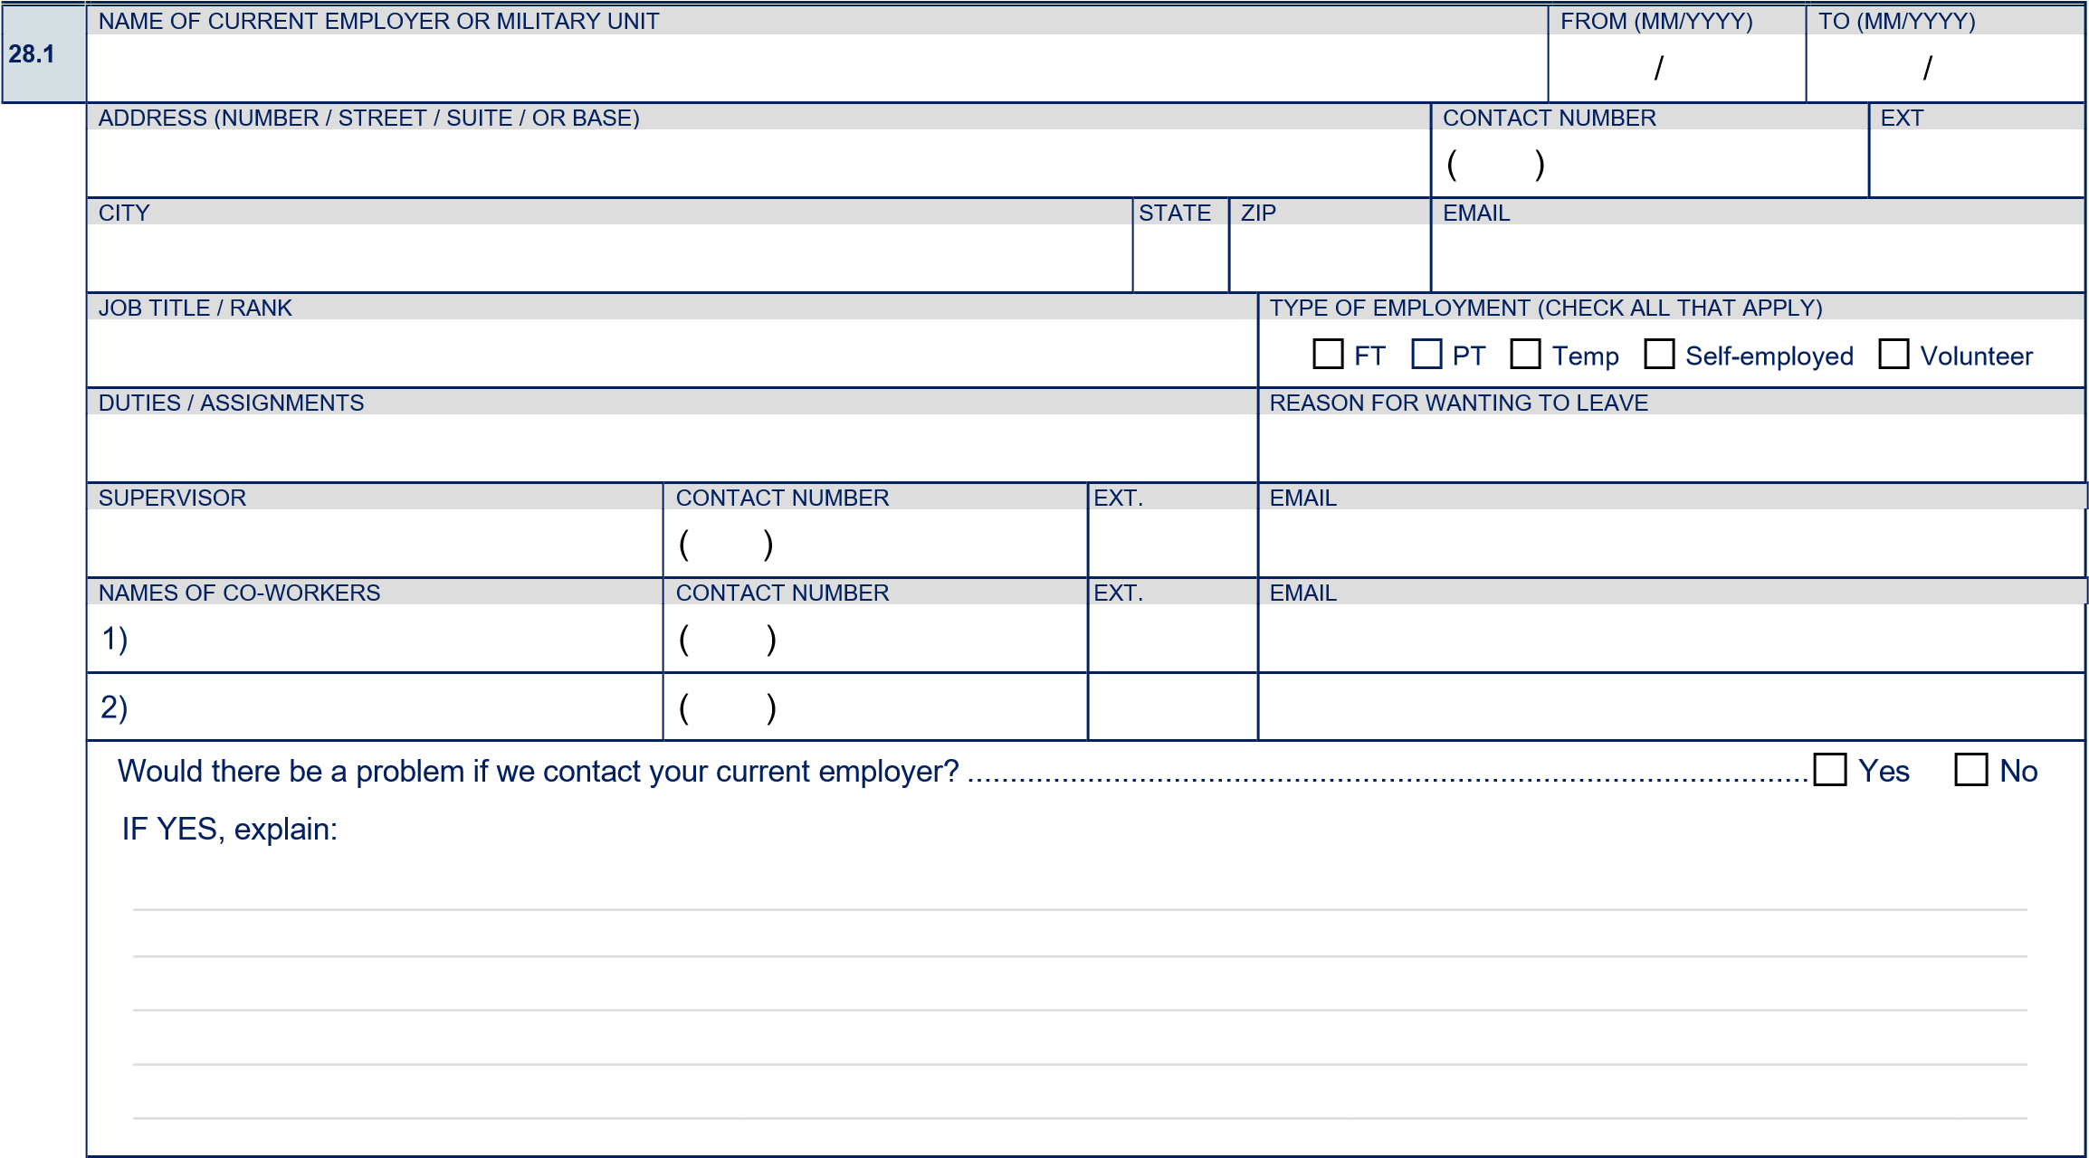

28.2 | PERIOD OF UNEMPLOYMENT (CHECK APPLICABLE)  Student Between jobs Leave of absence Travel Other: | FROM (MM/YYYY)  / | TO (MM/YYYY)  /

28.3 | NAME OF EMPLOYER OR MILITARY UNIT |  |  |  |  |  |  | FROM (MM/YYYY)  / | TO (MM/YYYY)  /
 | ADDRESS (NUMBER / STREET / SUITE / OR BASE) |  |  |  |  |  | CONTACT NUMBER ( ) |  |  | EXT
 | CITY |  |  | STATE | ZIP |  | EMAIL
 | JOB TITLE / RANK |  |  |  |  | TYPE OF EMPLOYMENT (CHECK ALL THAT APPLY)  FT PT Temp Self-employed Volunteer
 | DUTIES / ASSIGNMENTS |  |  |  |  | REASON FOR LEAVING
 | SUPERVISOR | CONTACT NUMBER  ( ) | EXT. |  |  | EMAIL
 | NAMES OF CO-WORKERS | CONTACT NUMBER | EXT. |  |  | EMAIL
 | 1) | ( )
 | 2) | ( )

28.4 | PERIOD OF UNEMPLOYMENT (CHECK APPLICABLE)  Student Between jobs Leave of absence Travel Other: | FROM (MM/YYYY)  / | TO (MM/YYYY)  /

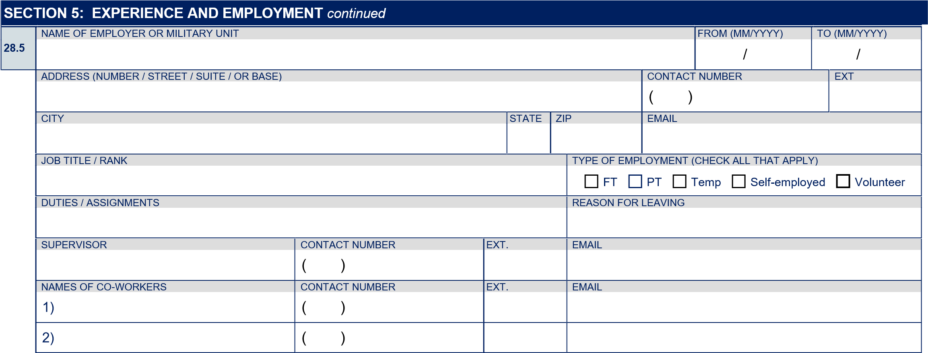

28.6 | PERIOD OF UNEMPLOYMENT (CHECK APPLICABLE)  Student Between jobs Leave of absence Travel Other: | FROM (MM/YYYY)  / | TO (MM/YYYY)  /

28.7 | NAME OF EMPLOYER OR MILITARY UNIT |  |  |  |  |  |  | FROM (MM/YYYY)  / | TO (MM/YYYY)  /
 | ADDRESS (NUMBER / STREET / SUITE / OR BASE) |  |  |  |  |  | CONTACT NUMBER ( ) |  |  | EXT
 | CITY |  |  | STATE | ZIP |  | EMAIL
 | JOB TITLE / RANK |  |  |  |  | TYPE OF EMPLOYMENT (CHECK ALL THAT APPLY)  FT PT Temp Self-employed Volunteer
 | DUTIES / ASSIGNMENTS |  |  |  |  | REASON FOR LEAVING
 | SUPERVISOR | CONTACT NUMBER ( ) | EXT. |  |  | EMAIL
 | NAMES OF CO-WORKERS | CONTACT NUMBER | EXT. |  |  | EMAIL
 | 1) | ( )
 | 2) | ( )

28.8 | PERIOD OF UNEMPLOYMENT (CHECK APPLICABLE)  Student Between jobs Leave of absence Travel Other: | FROM (MM/YYYY)  / | TO (MM/YYYY)  /

28.9 | NAME OF EMPLOYER OR MILITARY UNIT |  |  |  |  |  |  | FROM (MM/YYYY)  / | TO (MM/YYYY)  /
 | ADDRESS (NUMBER / STREET / SUITE / OR BASE) |  |  |  |  |  | CONTACT NUMBER ( ) |  |  | EXT
 | CITY |  |  | STATE | ZIP |  | EMAIL
 | JOB TITLE / RANK |  |  |  |  | TYPE OF EMPLOYMENT (CHECK ALL THAT APPLY)  FT PT Temp Self-employed Volunteer
 | DUTIES / ASSIGNMENTS |  |  |  |  | REASON FOR LEAVING
 | SUPERVISOR | CONTACT NUMBER  ( ) | EXT. |  |  | EMAIL
 | NAMES OF CO-WORKERS | CONTACT NUMBER | EXT. |  |  | EMAIL
 | 1) | ( )
 | 2) | ( )
SECTION 5: EXPERIENCE AND EMPLOYMENT
continued

28.10

PERIOD OF UNEMPLOYMENT (CHECK APPLICABLE)

FROM (MM/YYYY)

TO (MM/YYYY)

Student
Between jobs
Leave of absence
Travel
Other:

/

/

28.11 | NAME OF EMPLOYER OR MILITARY UNIT |  |  |  |  |  |  | FROM (MM/YYYY)  / | TO (MM/YYYY)  /
 | ADDRESS (NUMBER / STREET / SUITE / OR BASE) |  |  |  |  |  | CONTACT NUMBER ( ) |  |  | EXT
 | CITY |  |  | STATE | ZIP |  | EMAIL
 | JOB TITLE / RANK |  |  |  |  | TYPE OF EMPLOYMENT (CHECK ALL THAT APPLY)  FT PT Temp Self-employed Volunteer
 | DUTIES / ASSIGNMENTS |  |  |  |  | REASON FOR LEAVING
 | SUPERVISOR | CONTACT NUMBER ( ) | EXT. |  |  | EMAIL
 | NAMES OF CO-WORKERS | CONTACT NUMBER | EXT. |  |  | EMAIL
 | 1) | ( )
 | 2) | ( )

28.12 | PERIOD OF UNEMPLOYMENT (CHECK APPLICABLE)  Student Between jobs Leave of absence Travel Other: | FROM (MM/YYYY)  / | TO (MM/YYYY)  /

28.13 | NAME OF EMPLOYER OR MILITARY UNIT |  |  |  |  |  |  | FROM (MM/YYYY)  / | TO (MM/YYYY)  /
 | ADDRESS (NUMBER / STREET / SUITE / OR BASE) |  |  |  |  |  | CONTACT NUMBER ( ) |  |  | EXT
 | CITY |  |  | STATE | ZIP |  | EMAIL
 | JOB TITLE / RANK |  |  |  |  | TYPE OF EMPLOYMENT (CHECK ALL THAT APPLY)  FT PT Temp Self-employed Volunteer
 | DUTIES / ASSIGNMENTS |  |  |  |  | REASON FOR LEAVING
 | SUPERVISOR | CONTACT NUMBER ( ) | EXT. |  |  | EMAIL
 | NAMES OF CO-WORKERS | CONTACT NUMBER | EXT. |  |  | EMAIL
 | 1) | ( )
 | 2) | ( )

28.14 | PERIOD OF UNEMPLOYMENT (CHECK APPLICABLE)  Student Between jobs Leave of absence Travel Other: | FROM (MM/YYYY)  / | TO (MM/YYYY)  /

Supplemental employment information included on Page 25
29. | Have you ever been disciplined at work? (This includes written warnings, formal letters of counseling, reprimands, suspensions, reductions in pay, reassignments, or demotions.) .................................................................................. |  |  | Yes |  |  | No
30. | Have you ever been fired, released from probation, or asked to resign from any place of employment? ......................................... |  |  | Yes |  |  | No
31. | Were you ever involved in a physical/verbal altercation with a supervisor, co-worker, or customer? ............................................... |  |  | Yes |  |  | No
32. | Have you ever quit without giving proper notice? ............................................................................................................................ |  |  | Yes |  |  | No
33. | Have you ever resigned in lieu of termination? ................................................................................................................................ |  |  | Yes |  |  | No
34. | Have you ever been accused of discrimination (such as sexual harassment, racial bias, sexual orientation harassment, etc.) by a co-worker, superior, subordinate or customer? ........................................................................................................................ |  |  | Yes |  |  | No
SECTION 5: EXPERIENCE AND EMPLOYMENT continued
35. Were you ever the subject of a written complaint at work that resulted in disciplinary action against you? ...................................... Yes No
36. Have you ever been counseled at work due to lateness or absences? ............................................................................................ Yes No
37. Did you ever receive an unsatisfactory performance review? .......................................................................................................... Yes No
38. Have you ever sold, released, or given away legally confidential information? ................................................................................ Yes No
39. Have you ever called in sick when you were neither sick nor caring for a sick family member? .......................................................  IF YES, how many sick days have you used in the past five years which were not due to illness? _ _ Days |  |  | Yes |  |  | No
40. While working (i.e. on duty), have you ever engaged in sexual intercourse or the unwarranted touching of the intimate body parts of another person? (NOTE: Do not include lawful contact such as pat searches in law enforcement duties and/or training.) .. Yes No
41. While working (i.e. on duty), have you ever sent photographs of yourself or others, showing nudity or depicting sexual acts, to co-workers or other persons without prior authorization and/or consent? (NOTE: Do not include lawful exchange of
investigative content and/or evidence pursuant to official law enforcement investigations.) ............................................................. Yes No
If you answered “YES” to any of Questions 29–41, explain (include when, where, and circumstances – reference corresponding numbers).
________________________________ ______________________________________________________________________
______________________________________________________________________________________________________
______________________________________________________________________________________________________
______________________________________________________________________________________________________
______________________________________________________________________________________________________

______________________________________________________________________________________________________

Supplemental employment information included on Page 25
42. | In the past three years, have you missed days or been late to work due to drug or alcohol consumption? ......................................  If YES, how often? | Yes | No
43. | Has your work performance ever been affected by your use of alcohol or drugs? ...........................................................................  IF YES, when? Name of employer: | Yes | No
44. | In the past three years, have you been warned by an employer about your drinking or drug habits and their impact on your performance? .....................................................................................................................................................................  IF YES, when? Name of employer: | Yes | No

45. | Have you ever applied for any position at this or any other law enforcement agency (city, county, state, or federal)? .................... Yes |  |  |  |  |  |  |  |  |  |  |  |  |  |  |  |  |  |  |  |  |  |  | No
- If you answered “YES” to Question 45, list EVERY agency you have applied to, starting with the most recent.
- Give complete and accurate addresses.
- All agencies MUST be listed regardless of the outcome or current status. Check all boxes that apply for each agency.
- If more space is needed, continue your response on page 25.
45.1 |  | NAME OF LAW ENFORCEMENT AGENCY |  |  |  |  |  |  |  |  |  |  |  |  |  |  |  |  |  | DATE APPLIED (MM/YYYY)
 |  |  |  |  |  |  |  |  |  |  |  |  |  |  |  |  |  |  |  | /
 |  | ADDRESS (NUMBER / STREET) |  |  |  |  |  |  |  |  |  |  |  |  |  |  | BACKGROUND INVESTIGATOR’S NAME (IF KNOWN)
 |  | CITY |  |  |  |  |  |  |  |  |  |  | STATE | ZIP |  |  | CONTACT NUMBER ( ) |  |  |  |  |  | EXT
 |  | POSITION APPLIED FOR |  |  |  |  |  |  |  |  |  |  |  | EMAIL
 |  | CHECK EACH STEP IN THE PROCESS THAT YOU COMPLETED, AND YOUR STATUS:
 |  | STEP:  STATUS: |  | Application  Hired |  | Written On Eligibility List |  | Physical Ability  Withdrew |  | Oral Disqualified |  | Polygraph/CVSA  List Expired |  |  |  | Background Other (explain) |  |  | Chief’s Oral |  |  | Conditional Offer

SECTION 5: EXPERIENCE AND EMPLOYMENT continued
45.2 | NAME OF LAW ENFORCEMENT AGENCY |  |  |  |  |  |  |  |  |  |  |  |  |  |  |  |  |  |  |  | DATE APPLIED (MM/YYYY)
45.2 |  |  |  |  |  |  |  |  |  |  |  |  |  |  |  |  |  |  |  |  | /
 | ADDRESS (NUMBER / STREET) |  |  |  |  |  |  |  |  |  |  |  |  |  |  |  |  | BACKGROUND INVESTIGATOR’S NAME (IF KNOWN)
 | CITY |  |  |  |  |  |  |  |  |  |  |  |  | STATE | ZIP |  |  | CONTACT NUMBER |  |  |  |  |  | EXT
 |  |  |  |  |  |  |  |  |  |  |  |  |  |  |  |  |  | ( )
 | POSITION APPLIED FOR |  |  |  |  |  |  |  |  |  |  |  |  |  | EMAIL
 | CHECK EACH STEP IN THE PROCESS THAT YOU COMPLETED, AND YOUR STATUS:
 | STEP:  STATUS: |  | Application  Hired O |  | Written  Eligibility Li |  | Physical Ability  Withdrew |  | Oral  Disqualif |  |  |  | Polygraph/CVSA d List Expired |  |  |  | Background  Other (explai |  |  | Chief’s Oral |  |  | Conditional Offer
 | STEP:  STATUS: |  | Application  Hired O | n | Written  Eligibility Li | st | Physical Ability  Withdrew |  |  |  |  | ie |  |  |  |  |  |  | n)
45.3 | NAME OF LAW ENFORCEMENT AGENCY |  |  |  |  |  |  |  |  |  |  |  |  |  |  |  |  |  |  |  | DATE APPLIED (MM/YYYY) /
 | ADDRESS (NUMBER / STREET) |  |  |  |  |  |  |  |  |  |  |  |  |  |  |  |  | BACKGROUND INVESTIGATOR’S NAME (IF KNOWN)
 | CITY |  |  |  |  |  |  |  |  |  |  |  |  | STATE | ZIP |  |  | CONTACT NUMBER |  |  |  |  |  | EXT
 |  |  |  |  |  |  |  |  |  |  |  |  |  |  |  |  |  | ( )
 | POSITION APPLIED FOR |  |  |  |  |  |  |  |  |  |  |  |  |  | EMAIL
 | CHECK EACH STEP IN THE PROCESS THAT YOU COMPLETED, AND YOUR STATUS:
 | STEP:  STATUS: |  | Application  Hired O |  | Written  Eligibility Li |  | Physical Ability  Withdrew |  | Oral  Disqualif |  |  |  | Polygraph/CVSA d List Expired |  |  |  | Background  Other (explai |  |  | Chief’s Oral |  |  | Conditional Offer
 | STEP:  STATUS: |  | Application  Hired O | n | Written  Eligibility Li | st | Physical Ability  Withdrew |  |  |  |  | ie |  |  |  |  |  |  | n)
45.4 | NAME OF LAW ENFORCEMENT AGENCY |  |  |  |  |  |  |  |  |  |  |  |  |  |  |  |  |  |  |  | DATE APPLIED (MM/YYYY) /
 | ADDRESS (NUMBER / STREET) |  |  |  |  |  |  |  |  |  |  |  |  |  |  |  |  | BACKGROUND INVESTIGATOR’S NAME (IF KNOWN)
 | CITY |  |  |  |  |  |  |  |  |  |  |  |  | STATE | ZIP |  |  | CONTACT NUMBER |  |  |  |  |  | EXT
 |  |  |  |  |  |  |  |  |  |  |  |  |  |  |  |  |  | ( )
 | POSITION APPLIED FOR |  |  |  |  |  |  |  |  |  |  |  |  |  | EMAIL
 | CHECK EACH STEP IN THE PROCESS THAT YOU COMPLETED, AND YOUR STATUS:
 | STEP:  STATUS: |  | Application  Hired O |  | Written  Eligibility Li |  | Physical Ability  Withdrew |  | Oral  Disqualif |  |  |  | Polygraph/CVSA d List Expired |  |  |  | Background  Other (explai |  |  | Chief’s Oral |  |  | Conditional Offer
 | STEP:  STATUS: |  | Application  Hired O | n | Written  Eligibility Li | st | Physical Ability  Withdrew |  |  |  |  | ie |  |  |  |  |  |  | n)
45.5 | NAME OF LAW ENFORCEMENT AGENCY |  |  |  |  |  |  |  |  |  |  |  |  |  |  |  |  |  |  |  | DATE APPLIED (MM/YYYY) /
 | ADDRESS (NUMBER / STREET) |  |  |  |  |  |  |  |  |  |  |  |  |  |  |  |  | BACKGROUND INVESTIGATOR’S NAME (IF KNOWN)
 | CITY |  |  |  |  |  |  |  |  |  |  |  |  | STATE | ZIP |  |  | CONTACT NUMBER ( ) |  |  |  |  |  | EXT
 | POSITION APPLIED FOR |  |  |  |  |  |  |  |  |  |  |  |  |  | EMAIL
 | CHECK EACH STEP IN THE PROCESS THAT YOU COMPLETED, AND YOUR STATUS:
 | STEP: STATUS: |  | Application  Hired |  | Written On Eligibility List |  | Physical Ability  Withdrew |  | Oral Disqualified |  |  |  | Polygraph/CVSA  List Expired |  |  |  | Background Other (explain) |  |  | Chief’s Oral |  |  | Conditional Offer
SECTION 5: EXPERIENCE AND EMPLOYMENT continued
45.6 | NAME OF LAW ENFORCEMENT AGENCY |  |  |  |  |  |  |  |  |  |  |  |  |  |  |  |  |  |  |  | DATE APPLIED (MM/YYYY) /
 | ADDRESS (NUMBER / STREET) |  |  |  |  |  |  |  |  |  |  |  |  |  |  |  |  | BACKGROUND INVESTIGATOR’S NAME (IF KNOWN)
 | CITY |  |  |  |  |  |  |  |  |  |  |  |  | STATE | ZIP |  |  | CONTACT NUMBER |  |  |  |  |  | EXT
 |  |  |  |  |  |  |  |  |  |  |  |  |  |  |  |  |  | ( )
 | POSITION APPLIED FOR |  |  |  |  |  |  |  |  |  |  |  |  |  | EMAIL
 | CHECK EACH STEP IN THE PROCESS THAT YOU COMPLETED, AND YOUR STATUS:
 | STEP:  STATUS: |  | Application  Hired O |  | Written  Eligibility Li |  | Physical Ability  Withdrew |  | Oral  Disqualif |  |  |  | Polygraph/CVSA d List Expired |  |  |  | Background  Other (explai |  |  | Chief’s Oral |  |  | Conditional Offer
 | STEP:  STATUS: |  | Application  Hired O | n | Written  Eligibility Li | st | Physical Ability  Withdrew |  |  |  |  | ie |  |  |  |  |  |  | n)
45.7 | NAME OF LAW ENFORCEMENT AGENCY |  |  |  |  |  |  |  |  |  |  |  |  |  |  |  |  |  |  |  | DATE APPLIED (MM/YYYY) /
 | ADDRESS (NUMBER / STREET) |  |  |  |  |  |  |  |  |  |  |  |  |  |  |  |  | BACKGROUND INVESTIGATOR’S NAME (IF KNOWN)
 | CITY |  |  |  |  |  |  |  |  |  |  |  |  | STATE | ZIP |  |  | CONTACT NUMBER ( ) |  |  |  |  |  | EXT
 | POSITION APPLIED FOR |  |  |  |  |  |  |  |  |  |  |  |  |  | EMAIL
 | CHECK EACH STEP IN THE PROCESS THAT YOU COMPLETED, AND YOUR STATUS:
 | STEP:  STATUS: |  | Application  Hired |  | Written On Eligibility List |  | Physical Ability  Withdrew |  | Oral Disqualified |  |  |  | Polygraph/CVSA  List Expired |  |  |  | Background Other (explain) |  |  | Chief’s Oral |  |  | Conditional Offer
 | Supplemental employment information is included on Page 25

SECTION 6: MILITARY EXPERIENCE
46. Are you required to register for the Selective Service?.................................................................................................................... Yes No IF YES, have you registered? ......................................................................................................................................................... Yes No
IF NO, explain:
47. Have you ever served in the military? .......................................................................................................................................... Yes No

.
48
u answered “YES” to Question 47, include the following service information:
If yo

BRANCH OF SERVICE

FROM (MM/YYYY)

TO (MM/YYYY)

/

/

TYPE OF DISCHARGE

Entry Level
Honorable
General
OTH (Other than Honorable)

Bad Conduct
Dishonorable
Re-entry Code (1–4) if applicable –
refer to your DD-214:

49. | Are you currently participating in one of the following?  Military Reserve National Guard IF CHECKED, date obligation ends (MM/DD/YY):
50. | Have you ever been the subject of any judicial or non-judicial disciplinary action (such as, court martial, captain’s mast, office hours, company punishment)? ........................................................................................................................................... | Yes | No
51. | Were you ever denied a security clearance, or had a clearance revoked, suspended, or downgraded? ...................................... | Yes | No
52. | Have you ever taken military property without permission for personal use, to sell, or to give away? ........................................... | Yes | No

If you answered “YES” to any of Questions 50-52, explain (include dates and circumstances).
________________________________ _______________________________________________________________________ _______________________________________________________________________________________________________

Supplemental military information included on Page 25
SECTION 7: FINANCIAL
53. INCOME AND EXPENSES
- For each of the following questions (53A and B), fill in the amounts to the nearest dollar.
- For Question 53A: Provide your total monthly disposable income. Include money from investments, rental income, alimony, side businesses, etc.
- For Question 53B: Estimate your monthly living expenses. Include housing, utilities, credit cards or other loan payments, food, gas and car maintenance, entertainment, etc., as well as any other obligations you may have.
A) What is your total monthly disposable income? .......................................................................................... $ per month
B) How much do you spend each month? ....................................................................................................... $ per month
54. Have you ever filed for or declared bankruptcy (Chapter 7, 11 or 13)? ......................................................................................... Yes No
55. Have any of your bills ever been turned over to a collection agency? .......................................................................................... Yes No
56. Have you ever had purchased goods repossessed? .................................................................................................................... Yes No
57. Have your wages ever been garnished? ...................................................................................................................................... Yes No
58. Have you ever been delinquent on income or other tax payments? ............................................................................................. Yes No
59. Have you ever failed to file income tax or cheated/lied on an income tax form? ........................................................................... Yes No
60. Have you ever had an employment bond refused? ...................................................................................................................... Yes No
61. Have you ever avoided paying any lawful debt by moving away? ................................................................................................ Yes No
62. Have you ever defaulted on (failed to pay) a loan? ...................................................................................................................... Yes No
63. Have you ever borrowed money to pay for a gambling debt? ....................................................................................................... Yes No IF YES, do you currently have any outstanding debts as a result of gambling? ............................................................................ Yes No
64. Have you ever spent money for illegal purposes (e.g., illegal drugs, prostitution, purchase of fraudulent documents, etc.)? ........ Yes No
65. Have you ever failed to make or been late on a court-ordered payment (e.g., child support, alimony, restitution, etc.)? ............... Yes No
66. Have you written three or more bad checks in a one-year period? ............................................................................................... Yes No

If you answered “YES” to any of Questions 54-66, explain (include when, where, and why – reference corresponding numbers).
________________________________ _______________________________________________________________________
_______________________________________________________________________________________________________
_______________________________________________________________________________________________________
_______________________________________________________________________________________________________
_______________________________________________________________________________________________________
_______________________________________________________________________________________________________
_______________________________________________________________________________________________________
_______________________________________________________________________________________________________
_______________________________________________________________________________________________________
_______________________________________________________________________________________________________
_______________________________________________________________________________________________________
_______________________________________________________________________________________________________
_______________________________________________________________________________________________________
_______________________________________________________________________________________________________
_______________________________________________________________________________________________________
_______________________________________________________________________________________________________
_______________________________________________________________________________________________________

SECTION 8: LEGAL
◆ Disclosure of Arrests and Convictions
- This section requires you to report detentions, arrests, and convictions, including diversion programs that were not successfully completed, and in some cases, offenses that may have been pardoned. As a peace officer applicant, you are required to disclose this information, unless specifically exempted by state or federal law. It is strongly recommended that you consult with an attorney before omitting any information.
- If more space is needed, continue your response on page 25.

67. Have you EVER been detained by law enforcement for investigation, arrested, indicted, charged, or convicted of any
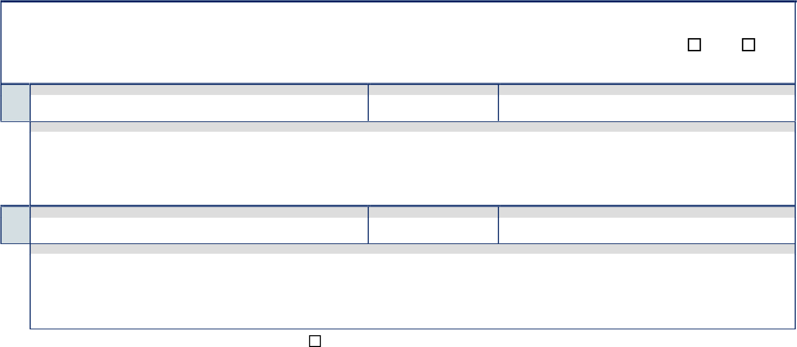
misdemeanor or felony offense in this state or any other legal jurisdiction (including offenses in the Uniform Code
of Military Justice)? ...................................................................................................................................................................... Yes No
IF YES, explain each incident:
CHARGE APPROX DATE (MM/YYYY) ARRESTING OR DETAINING AGENCY

67.1
/
DISPOSITION OR PENALTY

________________________________ _____________________________________________________________________
_____________________________________________________________________________________________________
_____________________________________________________________________________________________________
CHARGE APPROX DATE (MM/YYYY) ARRESTING OR DETAINING AGENCY

67.2
/
DISPOSITION OR PENALTY

________________________________ _____________________________________________________________________
_____________________________________________________________________________________________________
_____________________________________________________________________________________________________

Supplemental disclosure information included on Page 25

68. | Have you ever been placed on court probation? .......................................................................................................................... Yes No
69. | Were you ever required to appear before a juvenile court for an act which would have been a crime if  committed as an adult? ................................................................................................................................................................ Yes No
70. | Have you ever been a party in a civil lawsuit (e.g., small claims actions, dissolutions, child custody, paternity,
70. | support, etc.)? ............................................................................................................................................................................. |  | Yes |  | No
71. | Have the police ever been called to your home for any reason? .................................................................................................. Yes No
72. | Have you or your spouse/partner ever been referred to Child Protective Services? ..................................................................... Yes No
73. | Have you ever been the subject of an emergency protective order/restraining order/stay-away order? ........................................ Yes No
74. | Have you settled any civil suit in which you, your insurance company, or anyone else on your behalf was required  to make payment to the other party? ........................................................................................................................................... Yes No
75. | Have you ever fraudulently received welfare, unemployment compensation, workers’ compensation, or other state  or federal assistance? ................................................................................................................................................................. Yes No
76. | Have you ever been required to repay any welfare payments, unemployment compensation, or other state or  federal assistance? ...................................................................................................................................................................... Yes No
77. | Have you ever filed a false insurance or workers’ compensation claim? ...................................................................................... Yes No
If you answered “YES” to any of Questions 68-77, explain (include court case or document, dates, and circumstances – reference corresponding numbers). If more space is needed, continue your response on page 25.

________________________________ _______________________________________________________________________
_______________________________________________________________________________________________________
_______________________________________________________________________________________________________
_______________________________________________________________________________________________________
SECTION 8: LEGAL continued

◆ Involvement in Criminal Acts – Part 1
- Have you committed any of the following acts within the past seven (7) years? (You do NOT have to report any acts committed prior to age 15.)
    - You MUST include any acts committed at any time after you were first employed in law enforcement, including as a Police Explorer/ Police Cadet.

    - NOTE: You may NOT withhold any information regarding your involvement in any of the following acts, even if federal or state law relieved you from reporting the detention, arrest, or conviction that arose from it.
  - Animal abuse and/or neglect ................................................................................................................................................. Yes No
  - Annoying, obscene, or harassing contacts by telephone or other electronic communication device ....................................... Yes No
  - Battery (use of force or violence upon another) ........................................................................................................................ Yes No
  - Brandishing a weapon (any type of weapon) ............................................................................................................................ Yes No
  - Carrying a concealed weapon without a permit ........................................................................................................................ Yes No
  - Contributing to the delinquency of a minor ............................................................................................................................. Yes No
  - Defrauding an innkeeper (not paying for food or room at a hotel/motel, campground, etc.) .................................................... Yes No
  - Driving a vehicle or operating a boat/vessel while under the influence of alcohol and/or drugs .............................................. Yes No
  - Drunk in public (being so intoxicated in a public place that you’re not able to care for yourself) ............................................. Yes No
  - Filing a false police report ...................................................................................................................................................... Yes No
  - Hit & run collision (no injuries) .................................................................................................................................................. Yes No
  - Illegal gambling ........................................................................................................................................................................ Yes No
  - Illegal hunting and/or fishing (for example, without a license, out of season) ............................................................................ Yes No
  - Impersonating a peace officer (pretending to be a police officer) ........................................................................................... Yes No
  - Indecent exposure and/or lewd or obscene conduct .............................................................................................................. Yes No
  - Intentionally writing a bad check ............................................................................................................................................ Yes No
  - Joyriding (using a car or other vehicle without owner’s permission) .......................................................................................... Yes No
  - Peeping (including, but not limited to, looking through a window or opening with the intent to invade someone’s privacy) ........ Yes No
  - Petty theft (value up to $950, including shoplifting/switching price tags) .................................................................................. Yes No
  - Possession of alcohol as a minor (under the age of 21) ........................................................................................................... Yes No
  - Possession of falsified or altered identification, including use of another person’s ID (for any reason) ...................................... Yes No
  - Possession of stolen property (including, but not limited to, vehicles, credit/debit cards, etc.) ................................................... Yes No
  - Prostitution or solicitation of prostitution (including, but not limited to, patronizing illegal massage parlors) ............................... Yes No
  - Reckless driving ....................................................................................................................................................................... Yes No
  - Resisting arrest and/or delaying or obstructing an officer (including, but not limited to, running from the police) ....................... Yes No
  - Trespassing ............................................................................................................................................................................. Yes No
SECTION 8: LEGAL continued
78.27 | Vandalism (including, but not limited to, “tagging,” malicious mischief, and/or property damage) .............................................. Yes No
78.28 | Any other act amounting to a misdemeanor ............................................................................................................................. Yes No
- If you answered “YES” to ANY of the item(s) in Question 78, fully explain circumstances, including dates, names of individuals involved, and resolution. Reference the corresponding number (e.g., 78.5) for each explanation.
- If more space is needed, continue your response on page 25.
________________________________ _______________________________________________________________________
_______________________________________________________________________________________________________ _______________________________________________________________________________________________________

Supplemental legal information included on Page 25
 | ◆ Involvement in Criminal Acts – Part 2
 | 79. At any time in your life, have you EVER committed any of the following acts?
 | NOTE: You may NOT withhold any information regarding your involvement in any of the following acts, even if federal or state law relieved you from reporting the detention, arrest, or conviction that arose from it.
 | 79.1 |  | Arson (intentionally destroying property by setting a fire) ....................................................................................................... Yes No
 | 79.2 |  | Assault with a deadly weapon (struck or threatened to strike someone with an instrument likely to cause great bodily
 |  |  | injury or death) ...................................................................................................................................................................... |  | Yes |  |  | No
 | 79.3 |  | Blackmail or extortion ............................................................................................................................................................ Yes No
 | 79.4 |  | Burglary (entering a structure or vehicle to commit theft or other crime) ................................................................................ Yes No
 | 79.5 |  | Child molestation (performing unlawful acts with a child, inappropriate touching of a child) ................................................... Yes No
 | 79.6 |  | Elder abuse and/or neglect (physical and/or financial) ........................................................................................................... Yes No
 | 79.7 |  | Embezzlement (theft of money or other valuables entrusted to you) ...................................................................................... Yes No
 | 79.8 |  | Felony drunk driving (involving injuries) ................................................................................................................................. Yes No
 | 79.9 |  | Felony illegal sex acts ............................................................................................................................................................ Yes No
 | 79.10 |  | Forcible rape ......................................................................................................................................................................... Yes No
 | 79.11 |  | Forgery (falsifying any type of document, check certificate, license, currency, etc.) ............................................................... Yes No
 | 79.12 |  | Fraudulent use of a credit, ATM, debit, and/or check card ..................................................................................................... Yes No
 | 79.13 |  | Grand theft (value of over $950, automobile, any firearm) ..................................................................................................... Yes No
 | 79.14 |  | Hit & run (with injuries) .......................................................................................................................................................... Yes No
 | 79.15 |  | Hate crime ............................................................................................................................................................................. Yes No
 | 79.16 |  | Insurance fraud ..................................................................................................................................................................... Yes No
 | 79.17 |  | Murder, homicide, attempted murder, or assault with intent to commit murder ........................................................................ Yes No
 | 79.18 |  | Perjury (lying under oath) ...................................................................................................................................................... Yes No
 | 79.19 |  | Possession of an explosive/destructive device ...................................................................................................................... Yes No
 | 79.20 |  | Robbery (theft from another person using a weapon, force, or fear) ...................................................................................... Yes No
SECTION 8: LEGAL continued
79.21 |  | Stalking ................................................................................................................................................................................. |  |  |  | Yes |  |  | No
79.22 |  | Theft of a vehicle and/or vehicle parts ................................................................................................................................... |  |  |  | Yes |  |  | No
79.23 |  | Viewing and/or possessing child pornography ....................................................................................................................... |  |  |  | Yes |  |  | No
79.24 |  | Any other act amounting to a felony ...................................................................................................................................... |  |  |  | Yes |  |  | No
- If you answered “YES” to ANY of the item(s) in Question 79, fully explain circumstances, including dates, names of individuals involved, and resolution. Reference the corresponding number (e.g., 79.3) for each explanation.
- If more space is needed, continue your response on page 25.
_______________________________________________________________________________________________________
_______________________________________________________________________________________________________
_______________________________________________________________________________________________________
_______________________________________________________________________________________________________

◆ Illegal Use of Drugs
- For the purpose of responding to the following questions, “illegal drugs” include the unauthorized or illegal use of prescription medications or over-the-counter drugs; it also includes the illegal use of any other substance for the purpose of getting “high.”
- Your responses should include — but not be limited to — your use of any of the following:
  - Amphetamines / Methamphetamines (Uppers, Speed, Crank, etc)  Marijuana (with or without a prescription)
  - Barbiturates (Downers)  Mescaline
  - Cocaine / Crack Cocaine  Morphine
  - Designer Drugs (Ecstasy, Synthetic Heroin, etc.)  PCP / Angel Dust
  - GHB (Date Rape Drug)  Quaaludes
  - Hallucinogens (Peyote, LSD, Mushrooms)  Steroids
  - Hashish / Hashish Oil  Tetrahydrocannabinal (THC)
  - Heroin / Opium  Glue, paint, or any substance containing toluene
- Within the past six months, have you used any drug(s) as indicated above? ............................................................................ Yes No
IF YES, give details including drug(s) used, most recent date used, and circumstances:
________________________________ ______________________________________________________________________
______________________________________________________________________________________________________
______________________________________________________________________________________________________
- Prior to the past six months:
I have never used any drug recreationally.

I have tried or used one or more drugs, but only under limited circumstances (for example, experimentation, at parties, concerts, special events, etc.)
IF YOU CHECKED BOX 2, give details including drug(s) used, most recent date used, and circumstances:

_______________________________________________________________________________________________________
_______________________________________________________________________________________________________
_______________________________________________________________________________________________________
_______________________________________________________________________________________________________
_______________________________________________________________________________________________________

SECTION 8: LEGAL continued

82. Have you EVER engaged in any of the activities listed below involving drugs, narcotics or illegal substances, including marijuana and/or prescription drugs without a prescription? Yes No If YES, indicate which activities (mark all that apply):
Sold Manufactured Purchased Furnished Cultivated Carried or Held for Another
IF ANY ITEM IS CHECKED, give details including drug(s) involved, over what time period(s), and circumstances.

_______________________________________________________________________________________________________
_______________________________________________________________________________________________________

83. During the past five years, have you associated with friends, acquaintances, housemates, or family members who have illegally used drugs or narcotics, and/or illegally used prescription medications? .................................................................. Yes No IF YES, explain:

________________________________ _______________________________________________________________________
_______________________________________________________________________________________________________

Supplemental drug information included on Page 25

SECTION 9: MOTOR VEHICLE INFORMATION
84. Current Driver’s License:
 | STATE OF ISSUE | LICENSE NUMBER | EXPIRATION DATE (MM/DD/YYYY) / / | NAME UNDER WHICH LICENSE WAS GRANTED

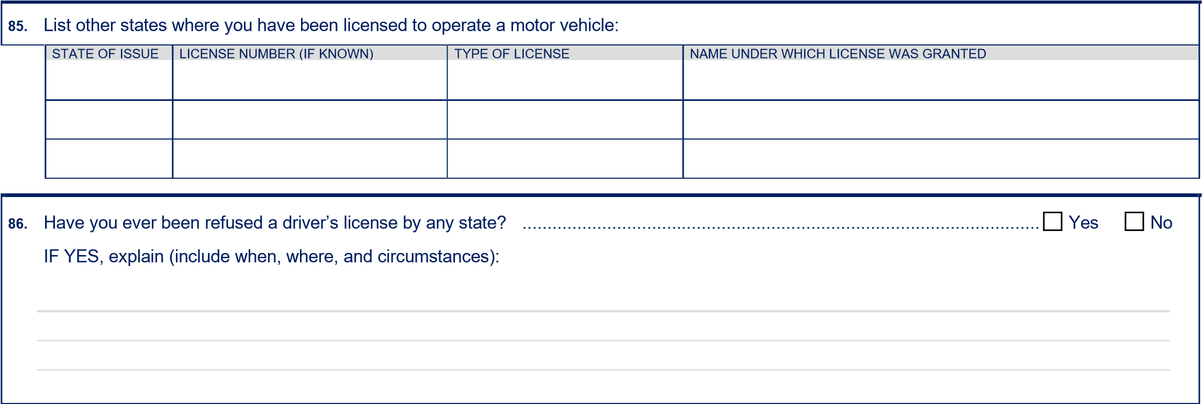

87. Has your driver’s license ever been suspended or revoked? ........................................................................................................ Yes No
IF YES, explain (include when, where, and circumstances):
________________________________ _______________________________________________________________________
_______________________________________________________________________________________________________
_______________________________________________________________________________________________________
_______________________________________________________________________________________________________
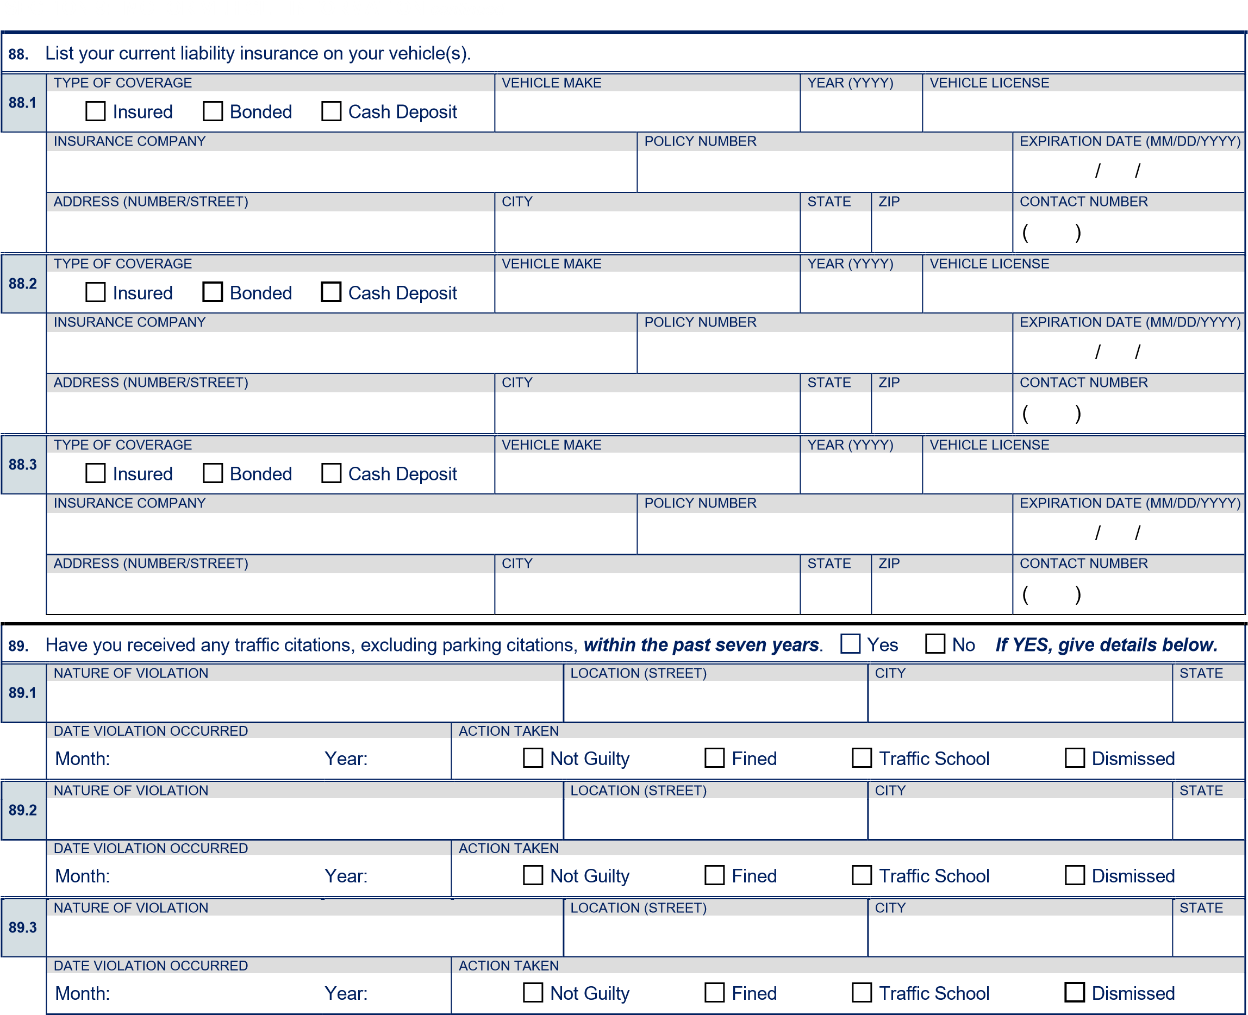

90. Has a traffic citation ever resulted in a warrant or caused your driver’s license to be withheld due to the following (check all that apply): Failed to Appear Failed to Complete Traffic School Failed to Pay the Required Fine
IF CHECKED, explain circumstances:
________________________________ ______________________________________________________________________
______________________________________________________________________________________________________

91. Have you been involved as the driver in a motor vehicle accident within the past seven years? .................................................. Yes No
IF YES, give details below.
 | 91.1 |  | DATE OF ACCIDENT (MM/YYYY)  / |  | LOCATION (STREET) | CITY |  |  | STATE
 |  |  | POLICE REPORT |  | LAW ENFORCEMENT AGENCY | AT FAULT? |  | WAS THE ACCIDENT?
 |  |  | Yes No |  |  | Yes | No | Injury Non-injury
 | 91.2 |  | DATE OF ACCIDENT (MM/YYYY)  / |  | LOCATION (STREET) | CITY |  |  | STATE
 |  |  | POLICE REPORT |  | LAW ENFORCEMENT AGENCY | AT FAULT? |  | WAS THE ACCIDENT?
 |  |  | Yes No |  |  | Yes | No | Injury Non-injury
SECTION 9: MOTOR VEHICLE INFORMATION continued
91.3 |  | DATE OF ACCIDENT (MM/YYYY)  / |  | LOCATION (STREET) |  | CITY |  |  | STATE
 |  | POLICE REPORT |  | LAW ENFORCEMENT AGENCY |  | AT FAULT? |  | WAS THE ACCIDENT?
 |  | Yes No |  |  |  | Yes No |  | Injury Non-injury

92. Have you ever driven a vehicle without auto insurance, as required by law? ................................................................................ |  |  |  | Yes No
 | IF YES, GIVE REASON |  | FROM (MM/YYYY) | TO (MM/YYYY)
 |  |  | / | /
93. Have you ever been refused automobile liability insurance or a bond, or had them cancelled? ..................................................... |  |  |  | Yes No
 | IF YES, GIVE REASON |  |  | DATE (MM/YYYY)
 |  |  |  | /
 |  | INSURANCE COMPANY

Supplemental motor vehicle information included on page 25
SECTION 10: OTHER TOPICS
94. Have you ever been refused a permit to carry a concealed weapon? ............................................................................................. | Yes No
95. Are you now, or have you ever been, a member or associate of a criminal enterprise, street gang, or any other group that advocates violence against individuals because of their race, religion, political affiliation, ethnic origin, nationality, gender, sexual preference, or disability?.........................................................................................................................................
 |  | Yes |  | No
96. Other than in self-defense, have you ever used force or violence against another person with whom you have had a dating, romantic or intimate relationship with, or who resided in the same household as you? ...................................................................
 |  | Yes |  | No
97. Since the age of 15, have you ever been involved in an anger-provoked physical fight, confrontation or other violent act? ........... | Yes No
98. Do you have, or have you ever had, a tattoo signifying membership in, or affiliation with, a criminal enterprise, street gang, or any other group that advocates violence against individuals because of their race, religion, political affiliation, ethnic origin, nationality, gender, sexual preference, or disability? ............................................................................................................
 |  | Yes |  | No

If you answered “YES” to any of Questions 94–98, give details including dates and circumstances – reference corresponding numbers).
________________________________ _______________________________________________________________________
_______________________________________________________________________________________________________
_______________________________________________________________________________________________________
_______________________________________________________________________________________________________
_______________________________________________________________________________________________________
_______________________________________________________________________________________________________
_______________________________________________________________________________________________________
_______________________________________________________________________________________________________
_______________________________________________________________________________________________________
_______________________________________________________________________________________________________
_______________________________________________________________________________________________________

SECTION 11: CERTIFICATION
99. I hereby certify that I have personally completed and initialed each page of this form and any attached supplemental page(s), and that all statements made are true and complete to the best of my knowledge and belief. I understand that any misstatement of material fact may subject me to disqualification; or, if I have been appointed, may disqualify me from continued employment.
Signature in Full:  Date:

Use the following page to continue your responses, if/as appropriate. Be sure to review all responses carefully and
provide additional information, as necessary. Reference corresponding question/item numbers.

POST 2-251 (Rev 02/2018)

SUPPLEMENTAL INFORMATION
•

Use this space to provide information that does not fit elsewhere on this form (e.g., additional family members, schools, residences, employers,
explanations to questions, etc.).
Reference the corresponding questions and/or specific items.
•

You may print copies of this page as needed. If you are filling in this page online, text will flow to additional pages automatically.

Page 25 of 25 Initial this page to indicate that you have provided complete and accurate information: _____

